**A PROJECT REPORT**

**ON**

**‘|Personal Album|’**

**CSE 326**



**[ASSIGNMENT]**

**BY**

* **Varun Gaur [11911046] 66**
* **Suman SK [11911060] 67**
* **Shubham Bharti [11910985] 64**
* **V Srinivasa Rao [11910999] 65**

**SECTION: K19KX**

DEPARTMENT OF COMPUTER SCIENCE ENGINEERING

**LOVELY PROFESSIONAL UNIVERSITY**

**CERTIFICATE**

This is to be certify that assignment Report entitled **“Website development (HTML5, CSS and javascript)”** which is submitted by our group member-

**( Varun gaur, Suman SK , Shubham bharti , Srinivasa rao )** in partial fulfilment of the requirement for the reward of degree of [Bachelor of technology in Stream Of Computer Science & engineering] of Lovely Professional University, is a record of the group work carried out by then under my supervision.

Date: 10 April 2020

Computer Science CSE(326):

Signature of teacher:

**ACKNOWLEDGEMENTS**

We would like to express our heartfelt gratitude to **Mrs. Amandeep Kaur** for giving us the opportunity to work under her guidance and help us gain immensely enriching professional experience. Our sincere thanks to project in charge and our internal project guide for giving us valuable inputs and ideas right from the selection of topic for project until its successful completion.

The successful completion of our project would not have been possible without the dedicated support from all our mentors, family and friends.

* VARUN GAUR
* SUMAN SK
* SHUBHAM BHARTI
* SRINIVASA RAO

**INTRODUCTION**

A **personal album** or  **photo album** is a series of photographic prints collected by an individual person or family in the form of a book. Some book-form photo albums have compartments which the photos may be slipped into; other albums have heavy paper with an abrasive surface covered with clear plastic sheets, on which surface photos can be put. Older style albums often were simply books of heavy paper on which photos could be glued to or attached to with adhesive corners or page .

We are creating a website which acts as the personal photo collection and album. The prototype of the album, is that the categories of photo collection and interactive visuals should be good. it should make you feel that you are experiencing them in real life.

**LANGUAGES USED**

In the development of this website, we have used three languages.

They are:

* HTML
* CSS
* JAVA SCRIPT

**HTML: HTML** (Hypertext Markup Language) is the most basic building block of the Web. It defines the meaning and structure of web content. Other technologies besides HTML are generally used to describe a web page's appearance/presentation (CSS) or functionality/ behaviour (Java Script)

"Hypertext" refers to links that connect web pages to one another, either within a single website or between websites. Links are a fundamental aspect of the Web. By uploading content to the Internet and linking it to pages created by other people, you become an active participant in the World Wide Web.

HTML uses "Markup" to annotate text, images, and other content for display in a Web browser. HTML Markup includes special "elements" such as <head>,<title>, <body>,<header>, <footer>, <article>, <p>, <div>, <img>,<audio>, <video>, <ul>, <a>, <li>,<a>, and many others.

An HTML element is set off from other text in a document by "tags", which consist of the element name surrounded by "<" and ">".  The name of an element inside a tag is case insensitive. That is, it can be written in uppercase, lowercase, or a mixture. For example, the <title> tag can be written as <Title>, <TITLE>, or in any other way.

**CSS: C**ascading **S**tyle **S**heets, fondly referred to as CSS, is a simple design language intended to simplify the process of making web pages presentable.

CSS handles the look and feel part of a web page. Using CSS, you can control the colour of the text, the style of fonts, the spacing between paragraphs, how columns are sized and laid out, what background images or colours are used, layout designs, variations in display for different devices and screen sizes as well as a variety of other effects.

CSS is easy to learn and understand but it provides powerful control over the presentation of an HTML document. Most commonly, CSS is combined with the markup languages HTML.

**JAVA SCRIPT:** Java Script is a programming language that adds interactivity to your website (for example games, responses when buttons are pressed or data is entered in forms, dynamic styling, and animation). This article helps you get started with this exciting language and gives you an idea of what is possible.

JavaScript ("JS" for short) is a full-fledged [dynamic programming language](https://developer.mozilla.org/en-US/docs/Glossary/Dynamic_programming_language) that, when applied to an HTML document, can provide dynamic interactivity on websites. It was invented by Brendan Eich , co-founder of the Mozilla project, the Mozilla Foundation, and the Mozilla Corporation.

JavaScript is incredibly versatile and beginner friendly. With more experience, you'll be able to create games, animated 2D and 3D graphics, comprehensive database-driven apps, and much more.

JavaScript itself is fairly compact yet very flexible. Developers have written a large variety of tools on top of the core JavaScript language, unlocking a vast amount of extra functionality with minimum effort.

**OBJECTIVES**

The objective of the ‘PERSONAL ALBUM’ is:

1. A photo book or personal album is a great way of remembering an occasion
2. There are plenty of social events where you’ll find a photo album incredibly useful , including;

Weddings: What better occasion to create a memorable photo album than in a wedding, whether you’re the bride, groom or just a regular guest. Wedding Photo Albums make a great gift for the bride and groom, offering a personal perspective on their special day.

Birthdays: Celebrate a birthday by creating an album for the lucky person, especially if they’ll struggle to remember the occasion.

1. Photo albums offer a great way to track and monitor the development of your children as they grow up.
2. Thanks to the many online photo services available on the the internet you can get others to create your very own album, in some cases all you have to do is send the photos you want and they’ll design and create a photo album to suit your needs.

**PURPOSE**

This website acts as a personal photo collection and album. The prototype of the album is that the categories of photo collection and interactive visuals should be good . there are plenty of events where you’ll find a photo album is incredibly useful. it creates a remembrance of all your memories.

**SCREENS DESIGN**

We have designed only one landing page which contains all pages .we have created everything in one page.

Here we will show some system interfaces that we have designed.

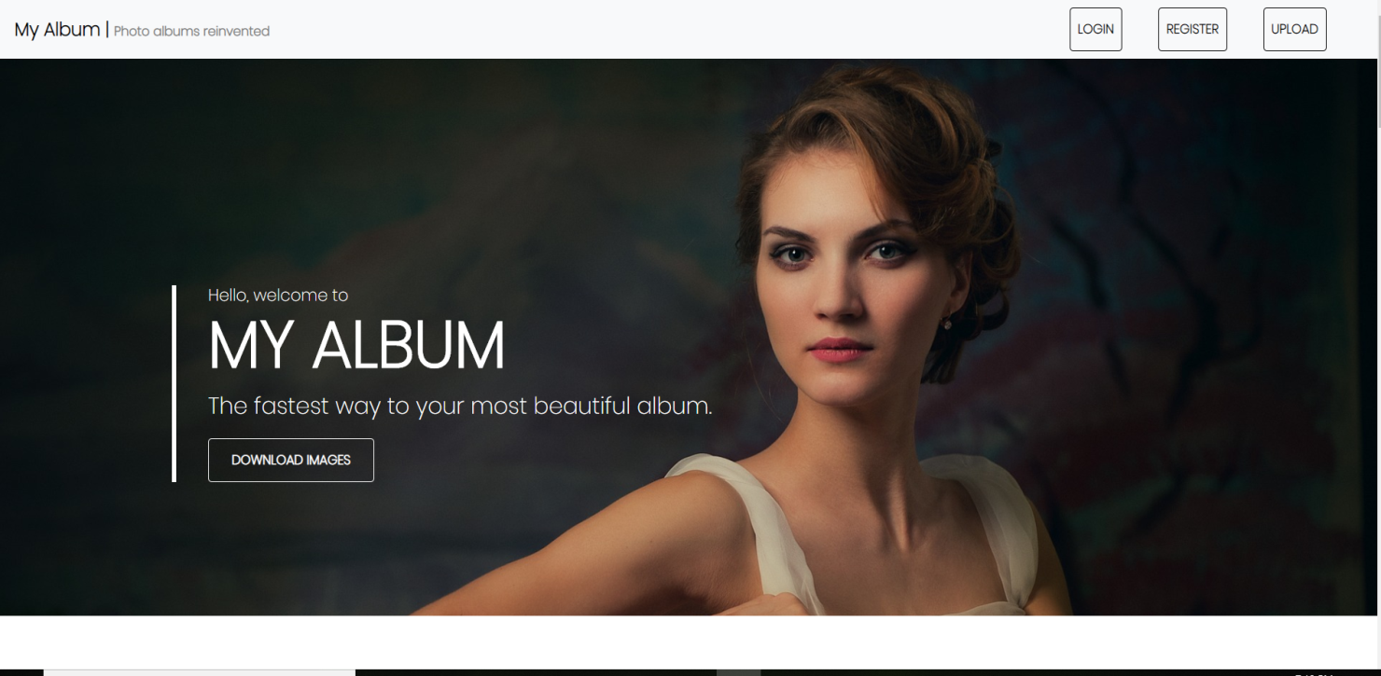 This is our landing page

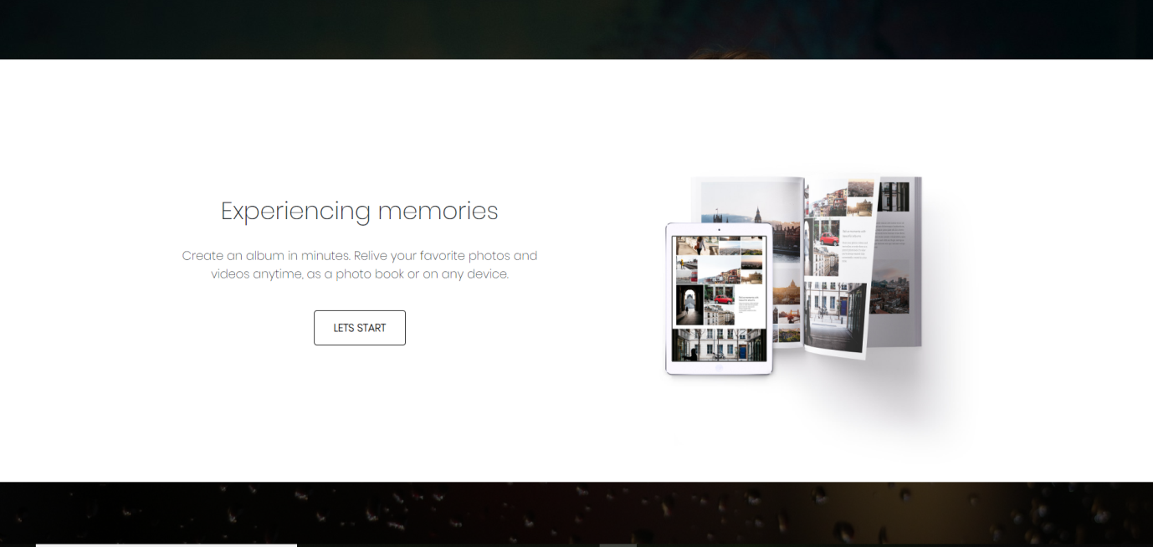

* This is the 2nd page which shows the categories of creating a album.

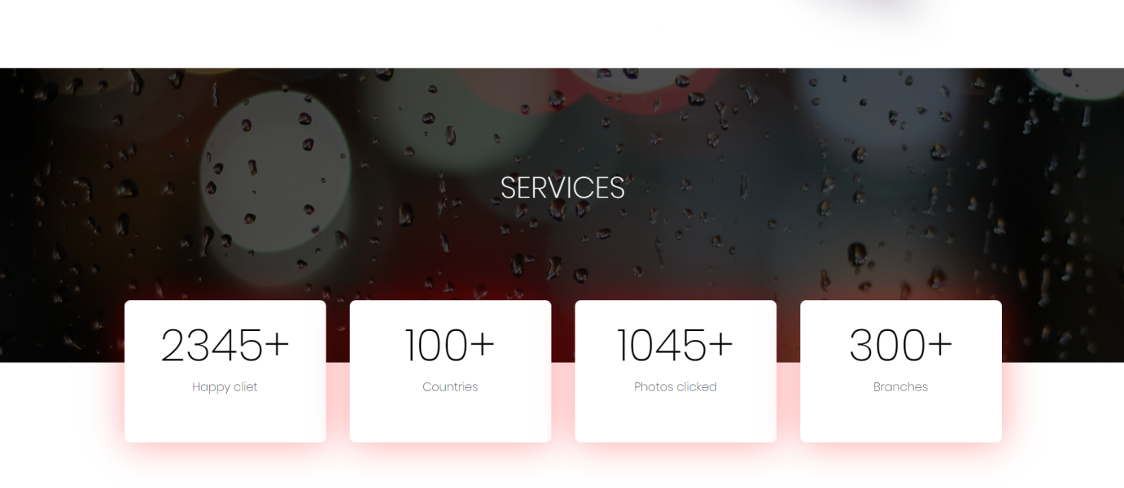

* This page shows our available services across the world and number of happy clients.

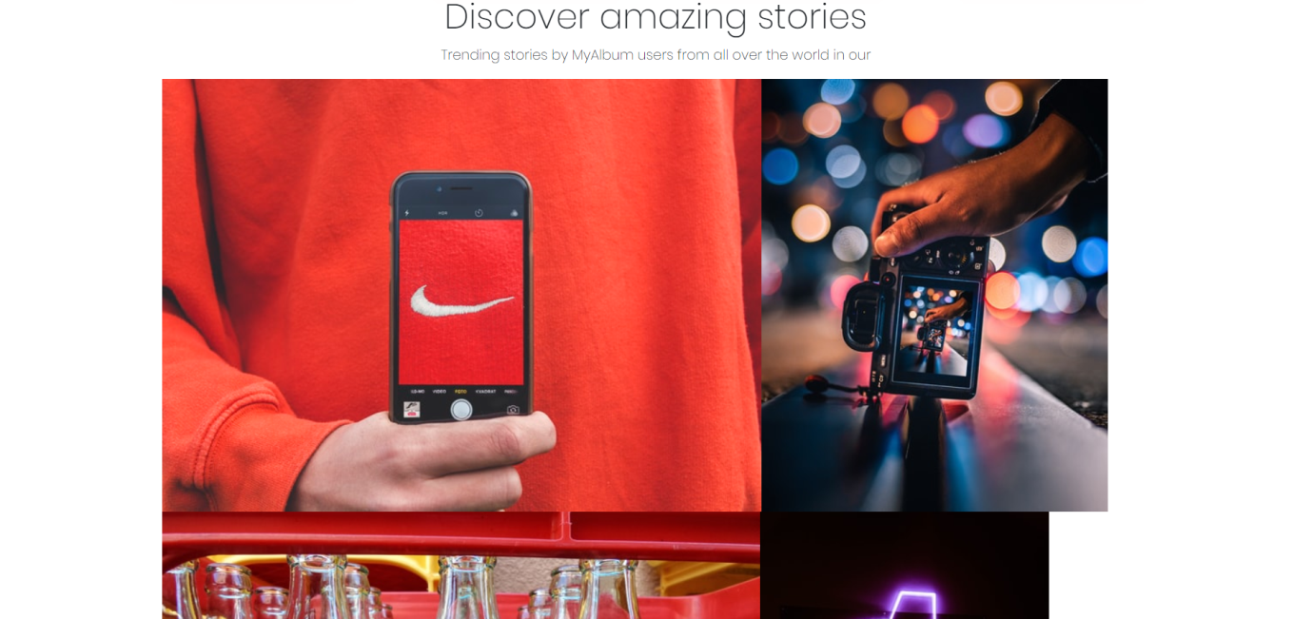

* This page shows how your photo album will look and you can discover your stories .

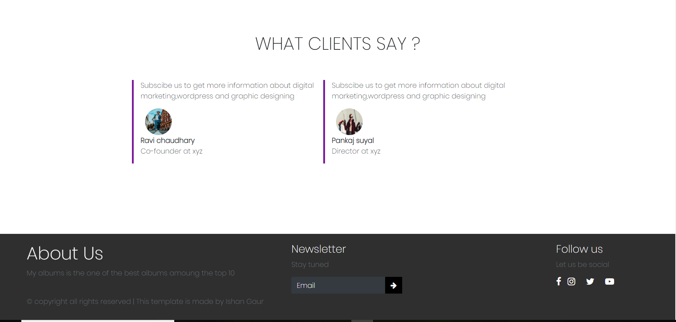

* This page shows the reviews of our client and tells about creators(we) our social accounts handles . and you can provide your feedback and put your email for more information about the website.

**JOB Distribution**

**FLOW CHART**

BIBLIOGRAPHY:

[www.google.com/designingwebpages](http://www.google.com/designingwebpages)

[www.wikipedia.com](http://www.wikipedia.com)

[www.myalbum.com](http://www.myalbum.com)

DESCRIPTION: The task each group member is going to perform is distributed evenly, he has a specific aspect of the webpage to design.Varun and shubhham are going to design the basic setup of the webpage, suman and srinivasa are going to look after the formatting and shubham and varun are going to manage the media and the links. The webpage requires multiple media components such as images and video previews. It also has multiple links and various sections which give out information about the personal photo collection.The webpage will be user friendly and informative. The user will be able to upload their photos and videos and can create an album from their collection.

**THANK YOU**

